Assignment 3

1. What is rdbms in sql?

RDBMS stands for Relational DataBase Management Systems. It is basically a program that allows us to create, delete, and update a relational database. Relational Database is a database system that stores and retrieves data in a tabular format organized in the form of rows and columns.

1. What is SQL?

SQL stands for Structured Query Language.

 SQL is a tool for organizing, managing, and retrieving archived data from a computer database. The original name was given by IBM as Structured English Query Language, abbreviated by the acronym SEQUEL. When data needs to be retrieved from a database, SQL is used to make the request. The [DBMS](https://www.geeksforgeeks.org/introduction-of-dbms-database-management-system-set-1/)processes the [SQL](https://www.geeksforgeeks.org/sql-tutorial/)query retrieves the requested data and returns it to us. Rather, [SQL](https://www.geeksforgeeks.org/sql-tutorial/)statements describe how a collection of data should be organized or what data should be extracted or added to the database.

1. Write SQL Commands?

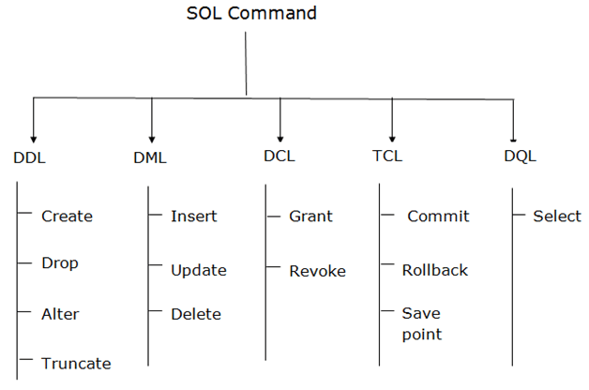

1. Data Definition Language (DDL)

* DDL changes the structure of the table like creating a table, deleting a table, altering a table, etc.
* All the command of DDL are auto-committed that means it permanently save all the changes in the database.

2. Data Manipulation Language

* DML commands are used to modify the database. It is responsible for all form of changes in the database.
* The command of DML is not auto-committed that means it can't permanently save all the changes in the database. They can be rollback.

### 3. Data Control Language

DCL commands are used to grant and take back authority from any database user.

### 4. Transaction Control Language

TCL commands can only use with DML commands like INSERT, DELETE and UPDATE only.

### 5. Data Query Language

DQL is used to fetch the data from the database.

1. What is join?

A JOIN clause is used to combine rows from two or more tables, based on a related column between them.

Then, we can create the following SQL statement (that contains an INNER JOIN),that selects records that have matching values in both tables:

* (INNER) JOIN: Returns records that have matching values in both tables
* LEFT (OUTER) JOIN: Returns all records from the left table, and the matched records from the right table
* RIGHT (OUTER) JOIN: Returns all records from the right table, and the matched records from the left table
* FULL (OUTER) JOIN: Returns all records when there is a match in either left or right table

How Many constraint and describes it self?

* **NOT NULL**: This constraint tells that we cannot store a null value in a column. That is, if a column is specified as NOT NULL then we will not be able to store null in this particular column any more.
* **UNIQUE**: This constraint when specified with a column, tells that all the values in the column must be unique. That is, the values in any row of a column must not be repeated.
* **PRIMARY KEY**: A primary key is a field which can uniquely identify each row in a table. And this constraint is used to specify a field in a table as primary key.
* **FOREIGN KEY**: A Foreign key is a field which can uniquely identify each row in a another table. And this constraint is used to specify a field as Foreign key.
* **CHECK**: This constraint helps to validate the values of a column to meet a particular condition. That is, it helps to ensure that the value stored in a column meets a specific condition.
* **DEFAULT**: This constraint specifies a default value for the column when no value is specified by the user.

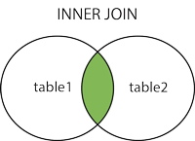  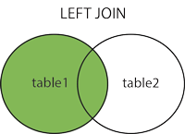  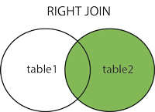  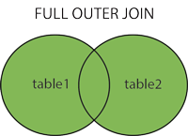

Difference between DBMS and RDBMS

|  |  |
| --- | --- |
| DBMS | RDBMS |
| DBMS applications store **data as file**. | RDBMS applications store **data in a tabular form** |
| In DBMS, data is generally stored in either a hierarchical form or a navigational form. | In RDBMS, the tables have an identifier called primary key and the data values are stored in the form of tables. |
| **Normalization is not** present in DBMS. | **Normalization is** present in RDBMS. |
| DBMS does **not apply any security** with regards to data manipulation. | RDBMS **defines the integrity constraint** for the purpose of ACID (Atomocity, Consistency, Isolation and Durability) property. |
| DBMS uses file system to store data, so there will be **no relation between the tables**. | in RDBMS, data values are stored in the form of tables, so a **relationship** between these data values will be stored in the form of a table as well. |
| DBMS has to provide some uniform methods to access the stored information. | RDBMS system supports a tabular structure of the data and a relationship between them to access the stored information. |
| DBMS **does not support distributed database**. | RDBMS **supports distributed database**. |
| DBMS is meant to be for small organization and **deal with small data**. it supports **single user**. | RDBMS is designed to **handle large amount of data**. it supports **multiple users**. |
| Examples of DBMS are file systems, **xml** etc. | Example of RDBMS are **mysql**, **postgre**, **sql server**, **oracle** etc. |

**What is API testing?**

**API Testing** is a software testing type that validates Application Programming Interfaces (APIs). The purpose of API Testing is to check the functionality, reliability, performance, and security of the programming interfaces

Type of API testing

Open API

Interface API

Composite API

**What is Responsive Testing?**

**Responsive** **testing** is a process that ensures a website works well on multiple devices by using CSS media queries based on the user's device where the website is accessed**.** It enables you to check how well a website looks and behaves on different devices, screen sizes, and resolutions**.**  The goal is to make sure the website can be used effectively on various devices, including desktops, laptops, table